**DAY 4 - BUILDING DYNAMIC FRONTEND COMPONENTS FOR YOUR MARKETPLACE**

This is the homepage of my website, which includes several key elements that provide a smooth and engaging user experience. The page features a **Navigation Bar** with **Contact** and **Blog** sections, allowing visitors to easily access your contact details or blog posts. There is also a **Card Shop** section where users can browse and shop their preferred products. A **Search Icon** is provided, enabling users to easily search for their desired items.

The **New Arrivals** section showcases the latest products, giving customers information about new items. A **Follow Instagram** button is included, allowing users to follow your Instagram page directly. The **Shop Now** button leads users to the shopping page, where they can purchase their preferred products. The **Blog** section is available for visitors to read posts, with a **Read More** option to explore the full details of the posts.

Lastly, the **View More** option provides access to additional content or products. The homepage also includes a brief description that offers basic information about your products and services.

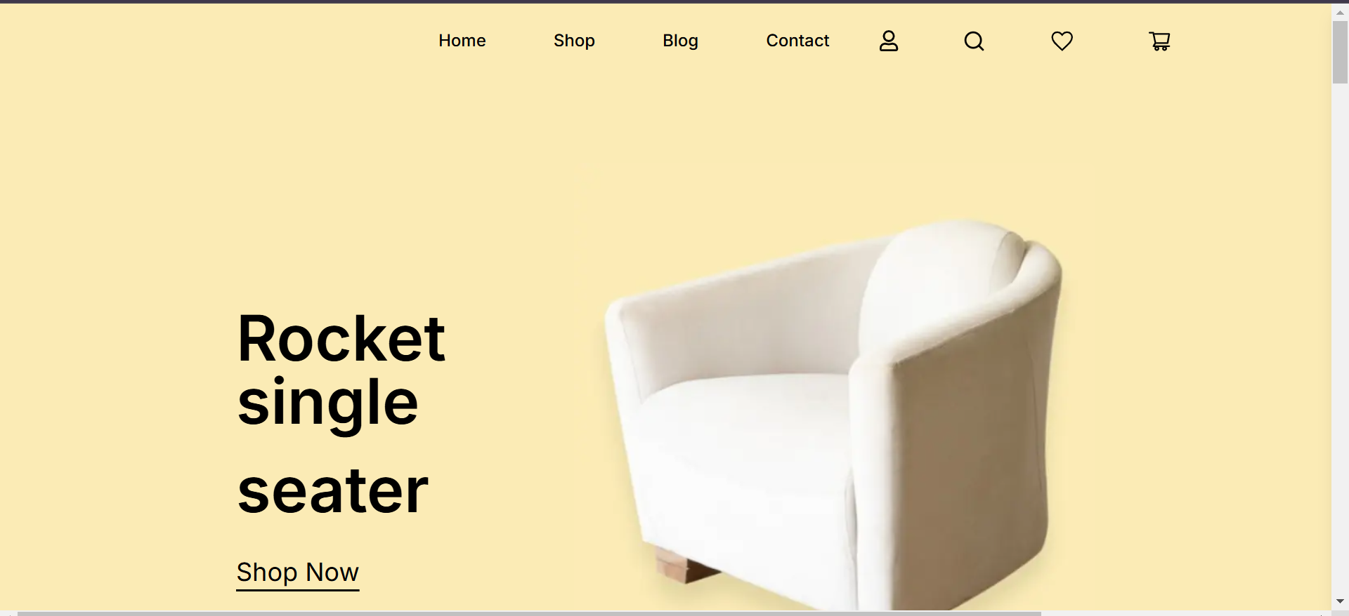

**Shop Page**

The **Shop Page** allows users to browse products, view their details, and add them to the cart. It displays a clean layout with product images, descriptions, and prices. Users can adjust quantities and see the total price. The page also includes a **Cart Totals** section, showing the subtotal and providing a **Checkout** button for easy purchase.

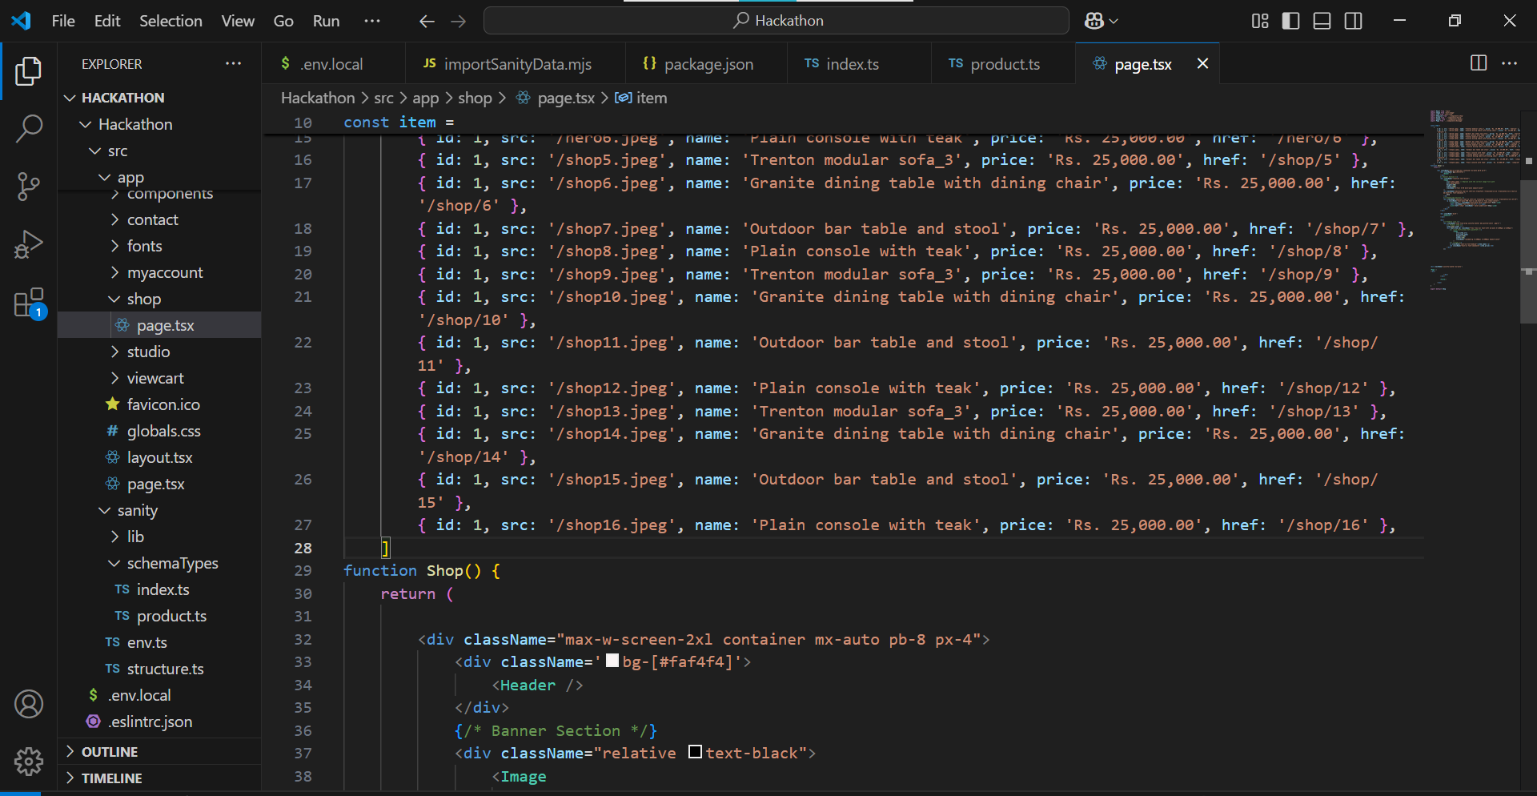

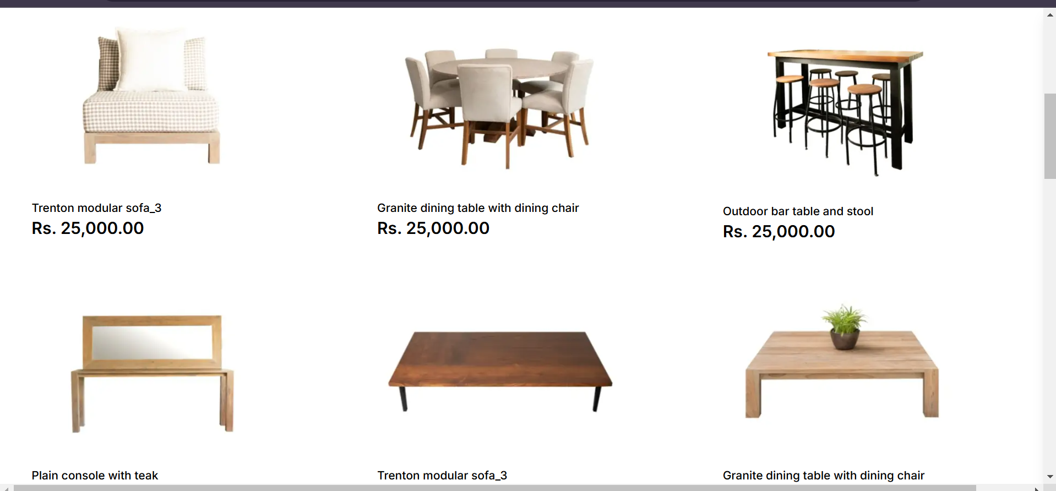

**Blog code,**

The **Blog Page** features a stylish and informative layout for displaying various blog posts. The page begins with a banner section containing an image, a title, and navigation links for easy access to the homepage and blog. Below the banner, the blog posts are showcased with attractive images, dates, categories, and a brief preview of the content. Each post includes a "Read More" link for detailed views. On the right side, a sidebar offers additional features such as a list of blog categories and recent posts, making it easy for visitors to explore more content.

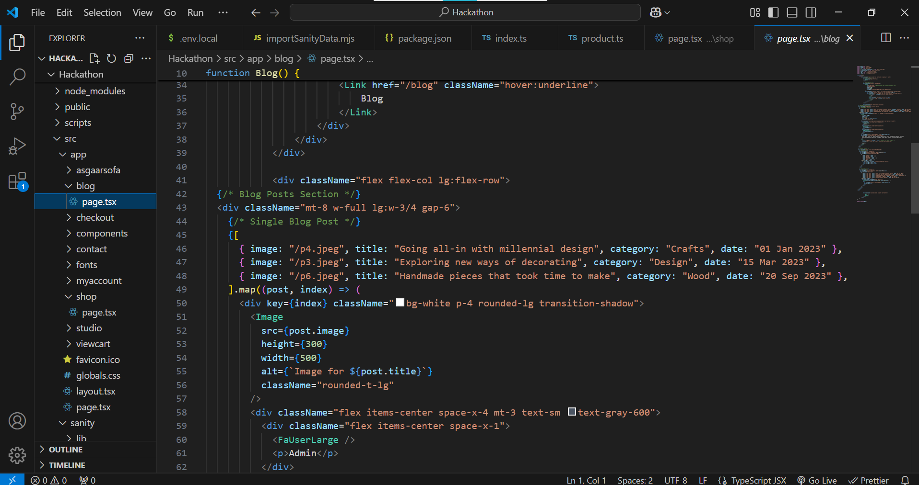

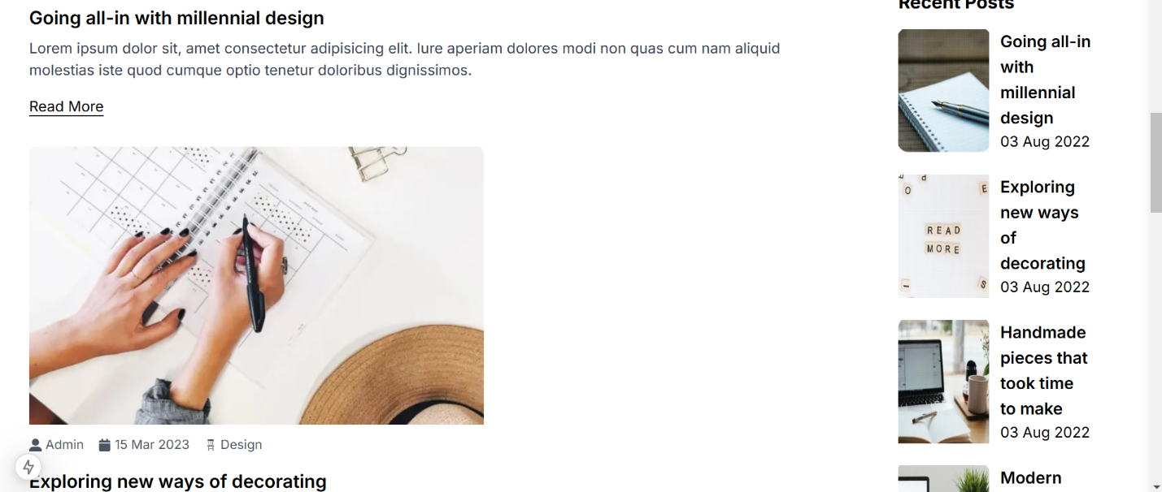

**Contact,**

The **Contact Page** features a banner with navigation, followed by contact details (address, phone, and working hours). It includes a simple contact form for users to submit inquiries, with fields for name, email, subject, and message, all designed for easy interaction.

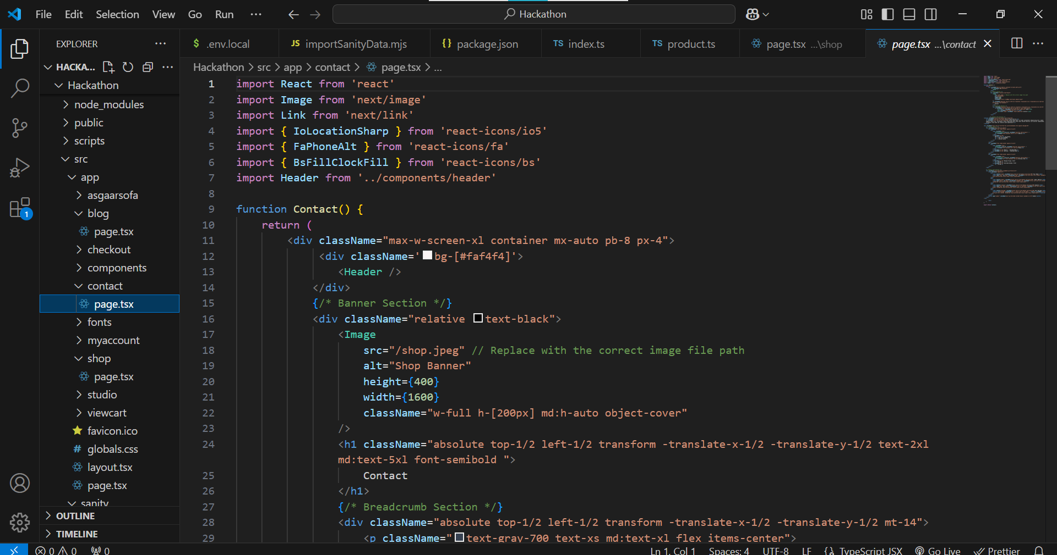

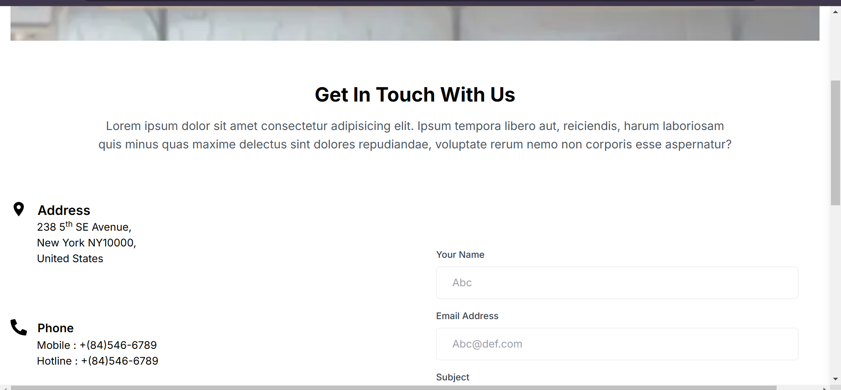

**MyAccount**

The MyAccount component displays a user account page with a banner, breadcrumb navigation, and two sections: one for login (username/email, password) and another for registration (email, privacy policy). Tailwind CSS is used for responsive design. The Field component is included at the bottom.

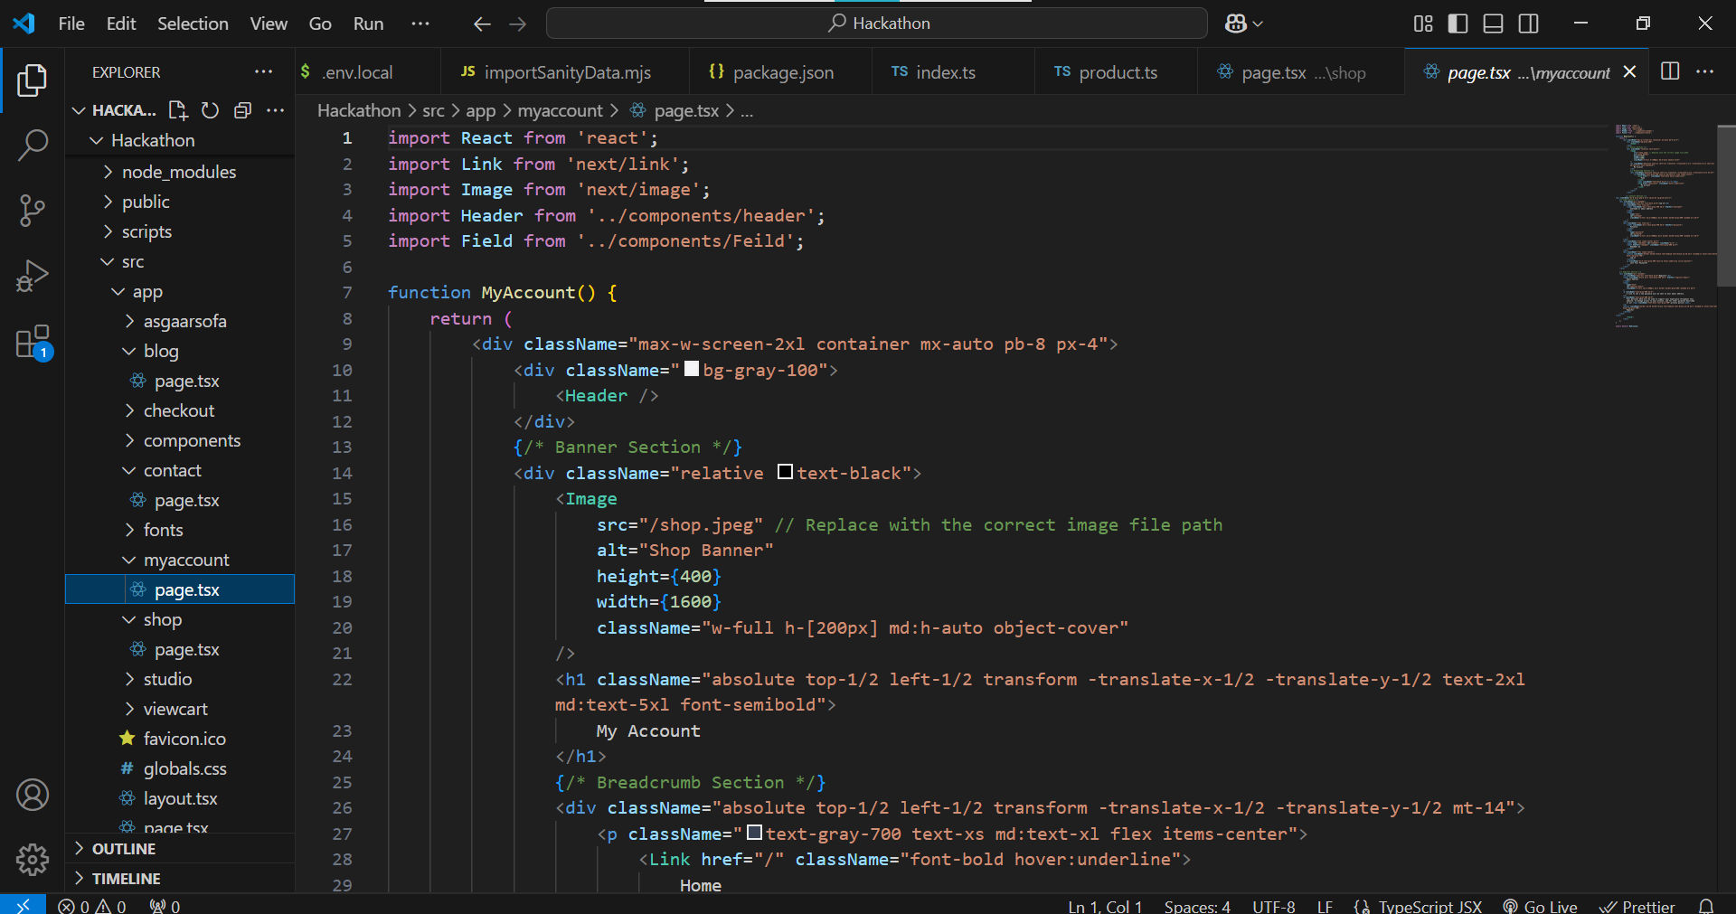

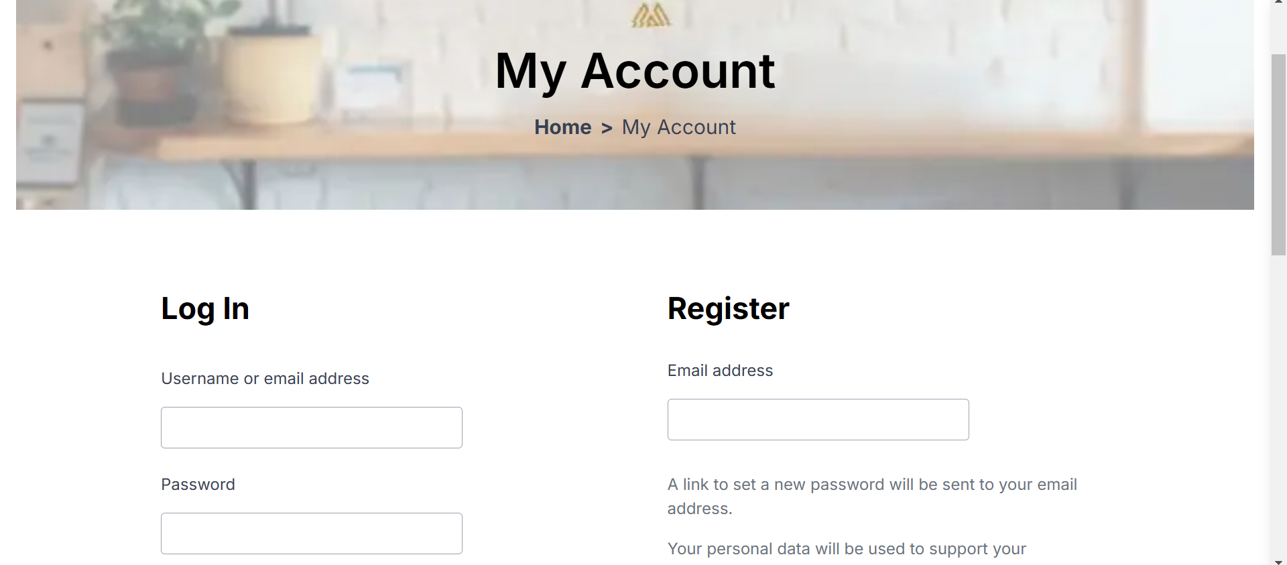

**Cart**

The ViewCart component represents the "Cart" page of an e-commerce website. It includes a banner with a title and breadcrumb navigation, followed by a table listing cart items with details such as product image, name, price, quantity, and subtotal. There is also a delete icon for removing items. On the right side, the cart totals are displayed, including the subtotal and total amount, with a checkout button. The layout is responsive, and Tailwind CSS is used for styling. The Field component is included at the bottom.

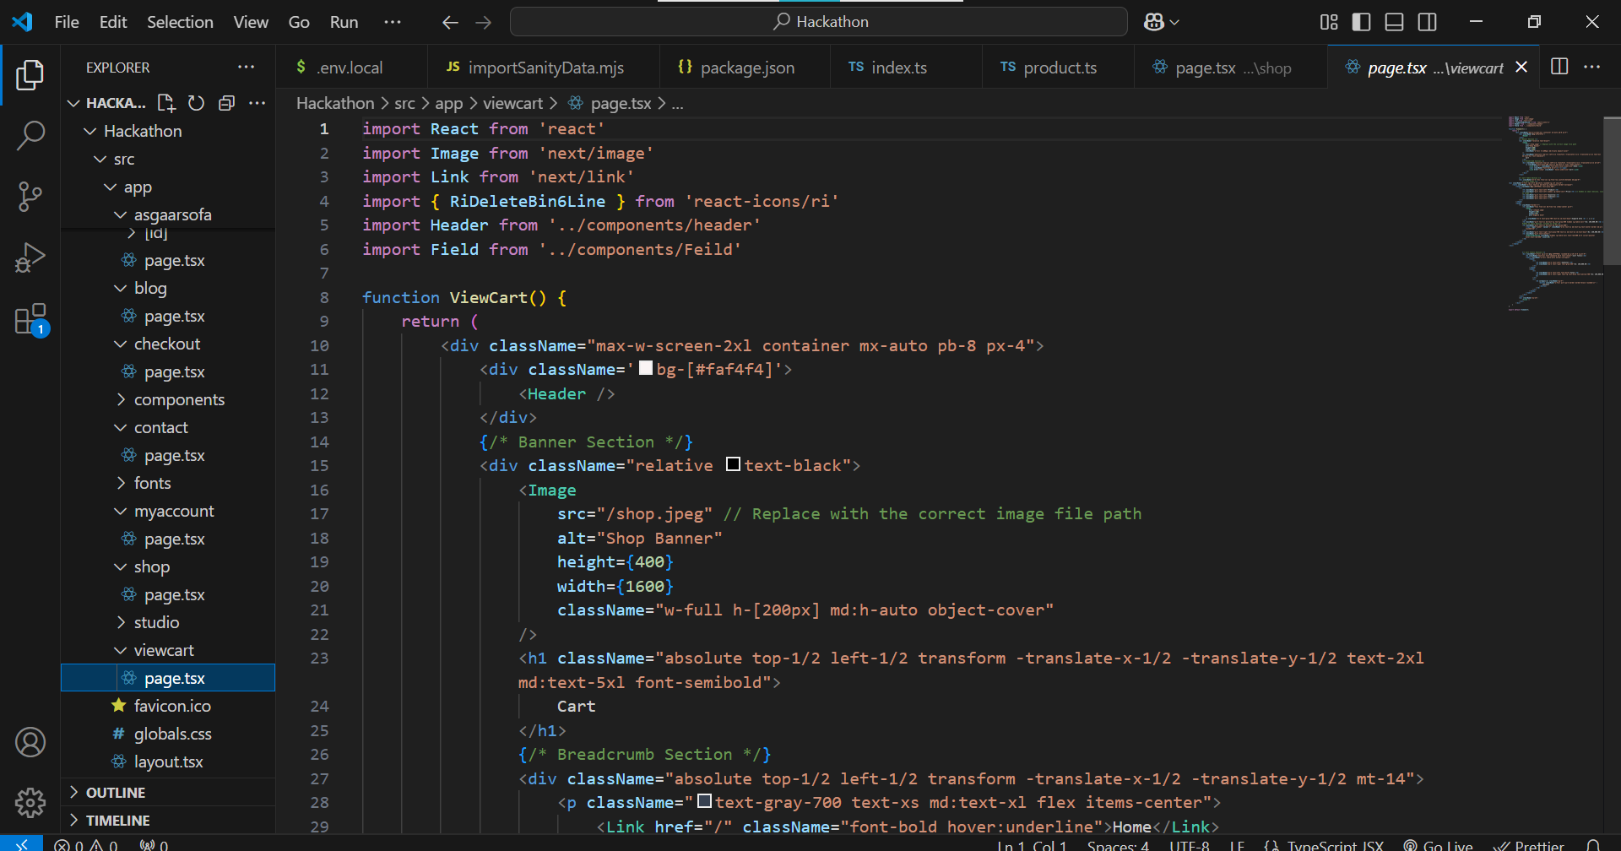

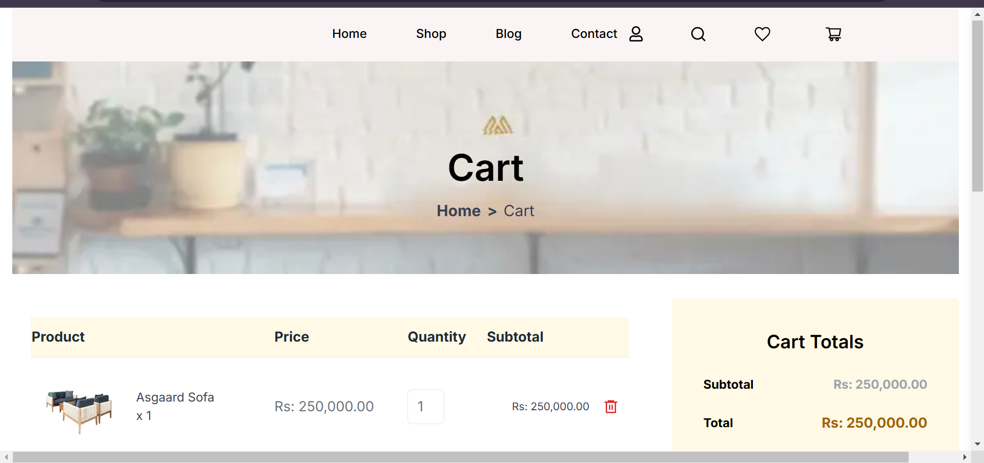

**Checkout page**

The **Checkout** page allows users to fill in their **billing details** (name, address, phone, email) and view an **order summary** with product details, subtotal, and total. It also provides payment options like **Direct Bank Transfer** and **Cash on Delivery**, with a button to **place the order**.

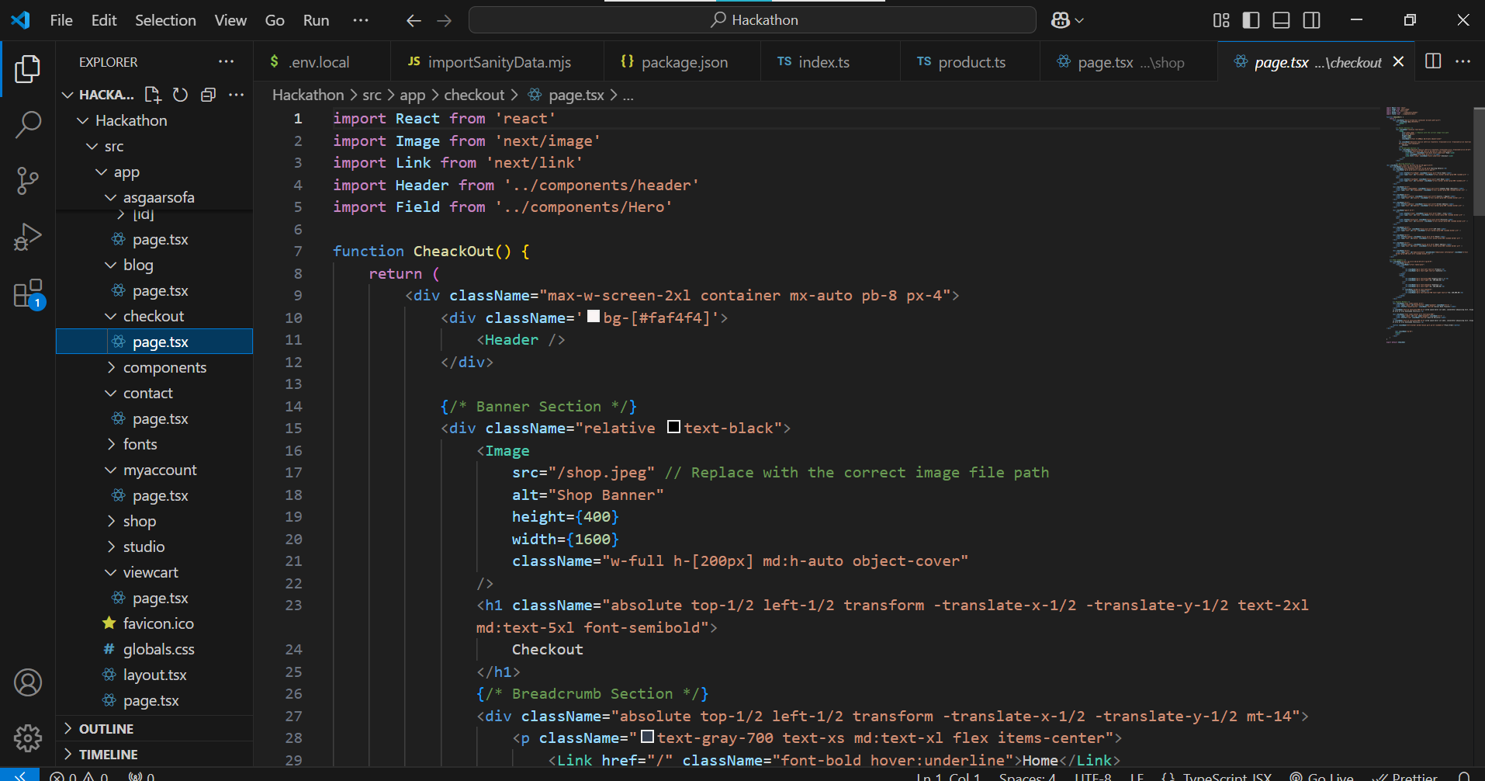

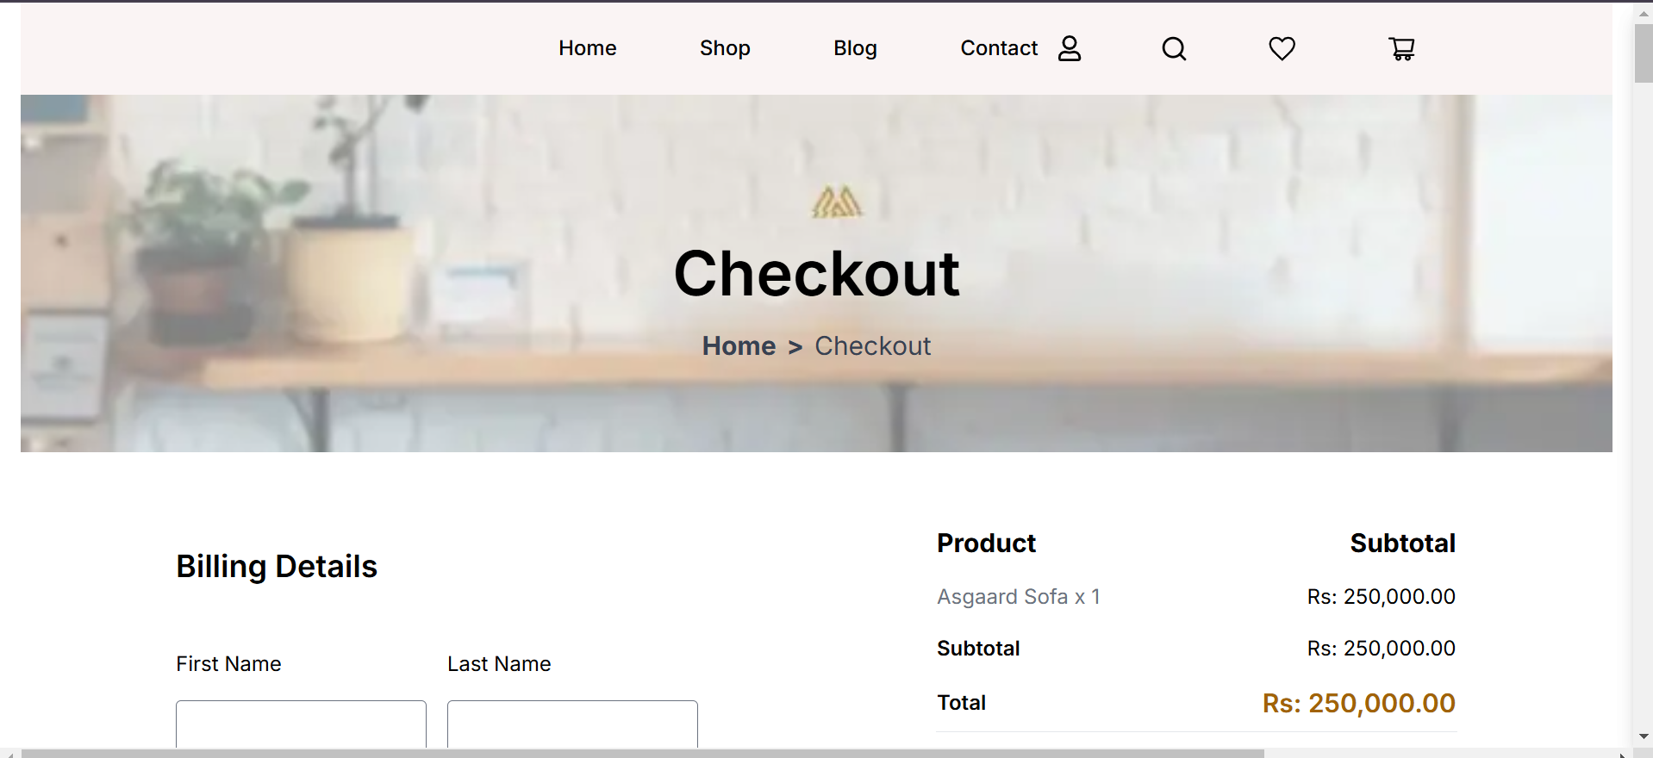

Product

The Product interface defines the structure of a product object, including properties like _id, productName, and a fixed _type of "product." It also has an optional _image property for product images, with a reference to the image asset. The price is required, while the description is optional, providing additional product details. This ensures consistent handling of product data from CMS or APIs.

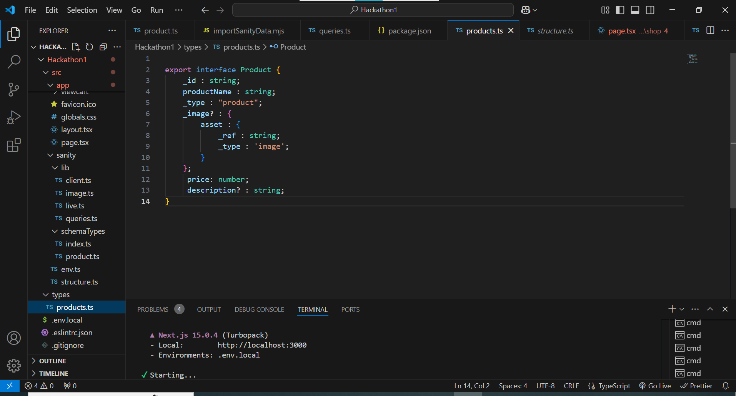

**Fetching Product Data from Sanity CMS using groq**

This code uses **groq** queries to fetch product data from Sanity CMS:

1. **allProducts**: Retrieves all products from the dataset.
2. **four**: Retrieves the first 4 products for optimization.

These queries dynamically fetch product information for efficient display on the frontend.

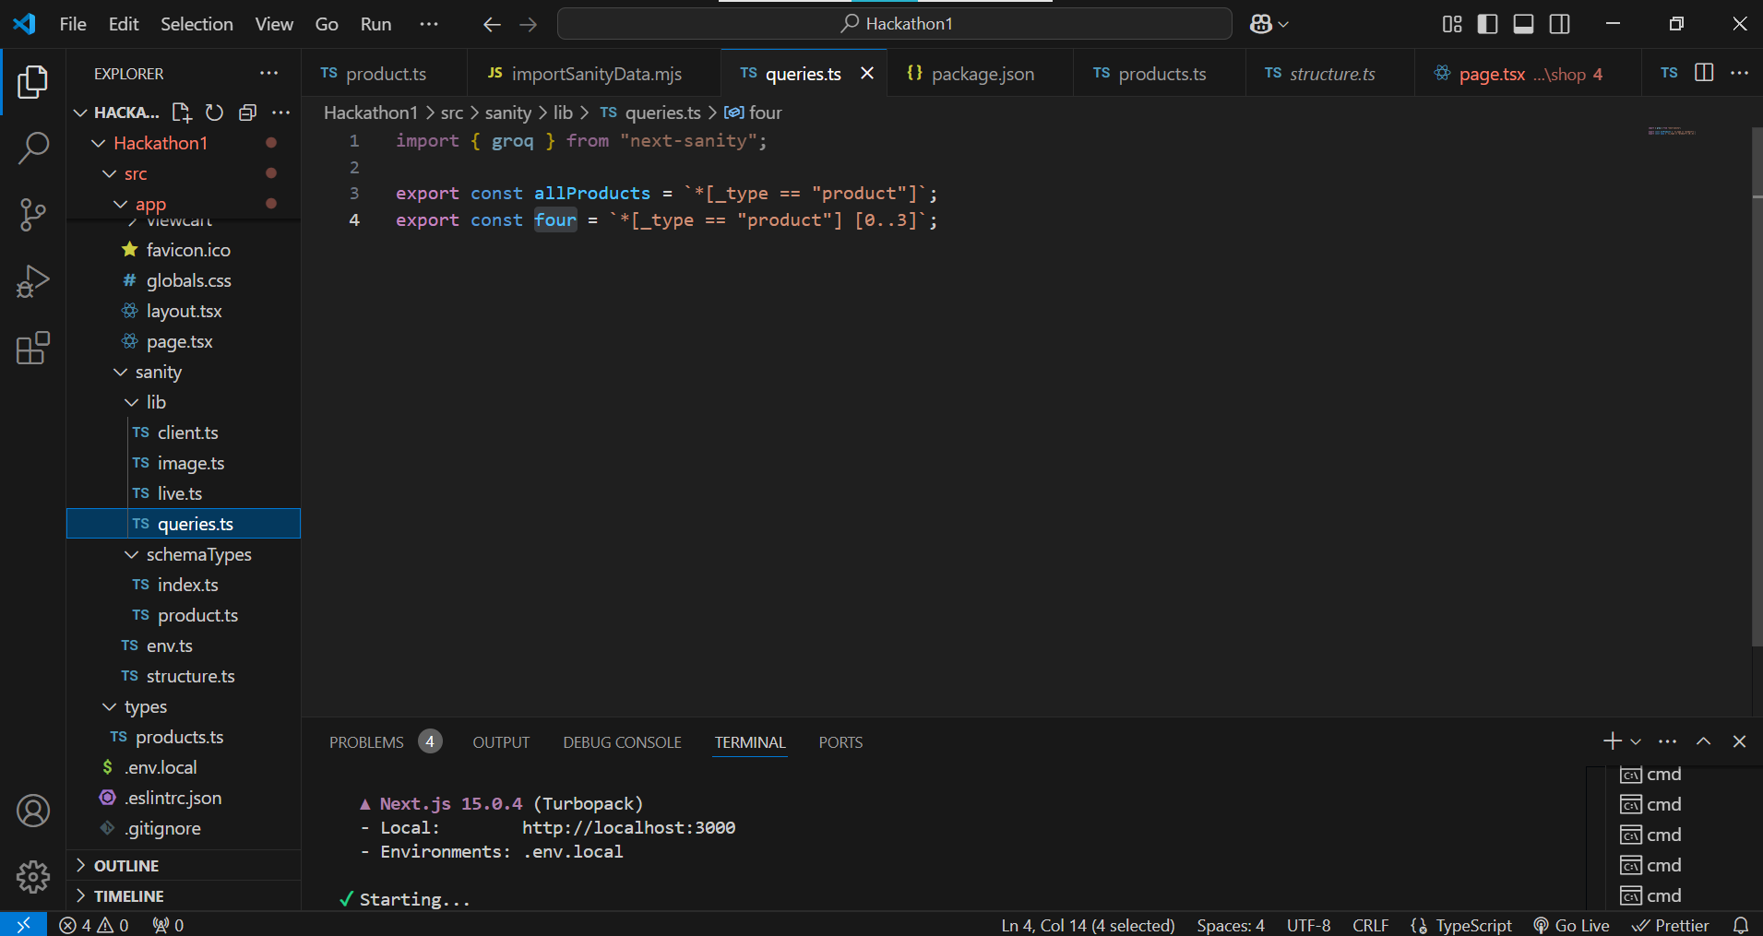

**Fetching and Displaying Marketplace Data from Sanity CMS**

I integrated Sanity CMS to fetch real-time marketplace data via its API. This data, including product details like titles, descriptions, and images, was dynamically displayed on frontend components like product cards. Using JavaScript (or React/Next.js), I ensured the marketplace page updates automatically, providing a seamless and interactive user experience. 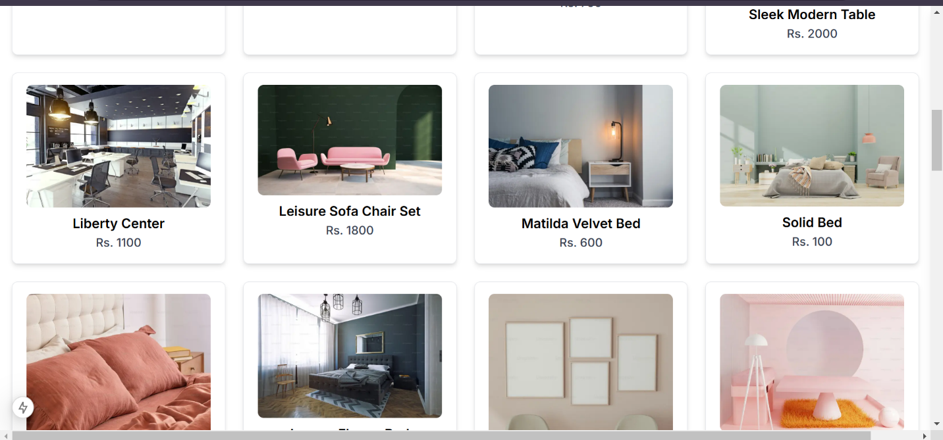

**Backend Development**

Using Google and GitHub authentication allows users to quickly log in without needing to create new accounts. It enhances security by leveraging established authentication methods, reduces password management concerns, and improves user experience by streamlining the login process.

**Payment Gateway Integration**

We are integrating **Stripe**, **EasyPaisa**, **JazzCash**, and **PayPal** into our website to offer users multiple payment options. This provides convenience, security, and flexibility for both local and international transactions. **Stripe** allows credit and debit card payments, **EasyPaisa** and **JazzCash** cater to mobile payments in Pakistan, while **PayPal** supports global online transactions. This integration ensures a seamless and secure payment experience for our customers.

**Component Integration**

Our website integrates essential features like **Cart**, **User Profile**, **Wishlist**, and **Checkout** to enhance the shopping experience. The **Cart** allows users to add and review items, while the **User Profile** stores personal details for easy access. The **Wishlist** enables users to save favorite items for future purchases, and the **Checkout** process is streamlined for quick and secure transactions. These features work together to provide a seamless and personalized shopping journey.

**Conclusion**:

By integrating payment gateways like **Stripe**, **EasyPaisa**, **JazzCash**, and **PayPal**, and enabling **Google** and **GitHub** authentication, the website offers a secure, convenient, and efficient experience for users. The combination of smooth login methods and diverse payment options enhances user satisfaction and boosts trust, streamlining both the shopping and account management process.